**Experiment 7**

**Aim:** Create pipeline using the Blue Ocean plugin

**Procedure:**

**Step 1:** Install the blue ocean plugin.

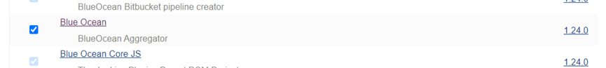

**Step 2:** Click on the open Blue Ocean in Jenkins.

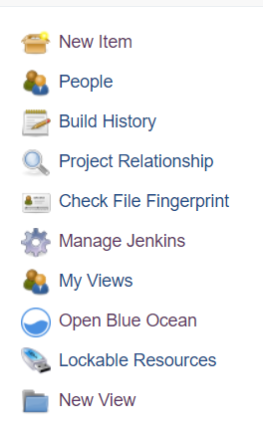

On clicking on the option we would be redirected to the blue ocean dashboard:

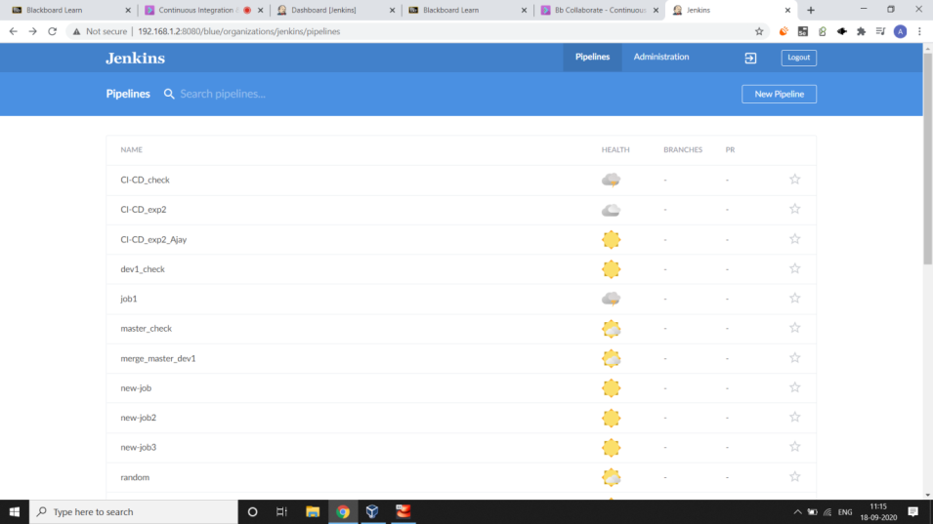

**Step 3:** Click on create pipeline and configure blue ocean as follows:

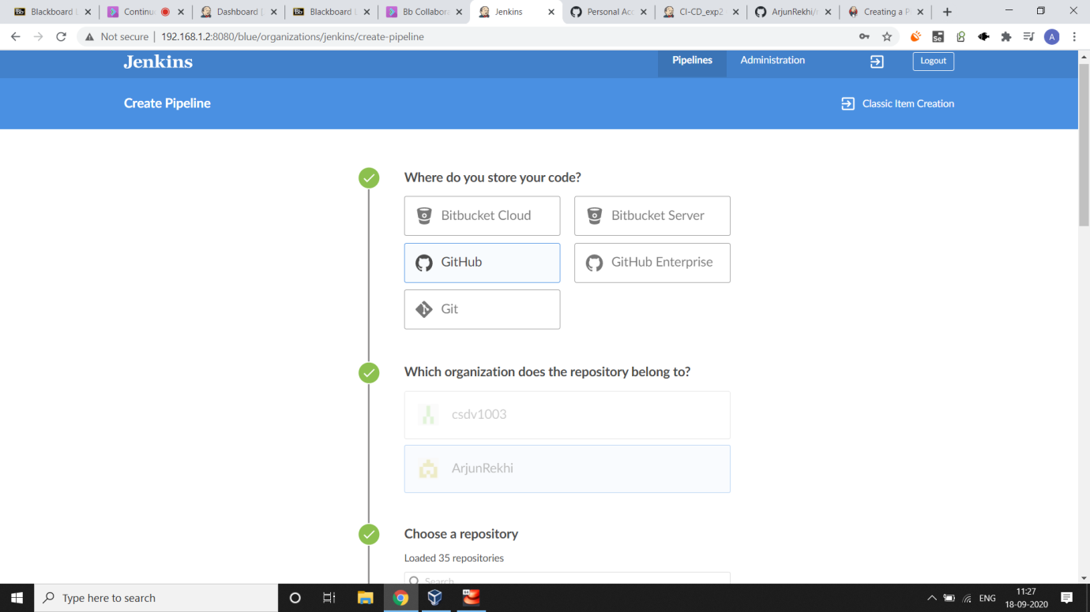

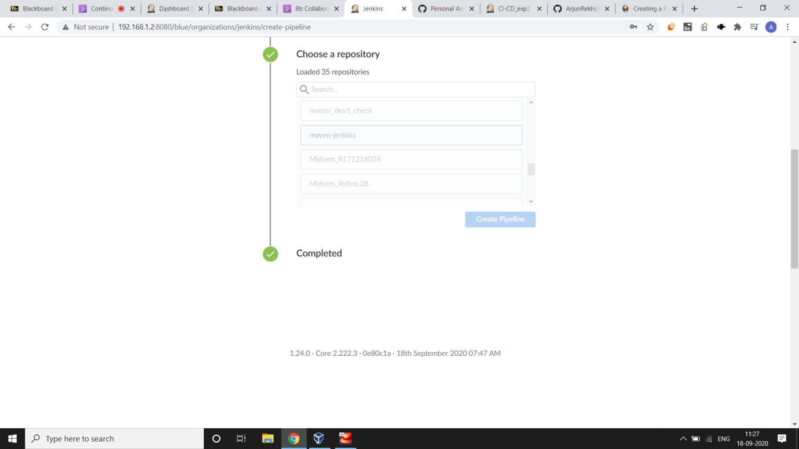

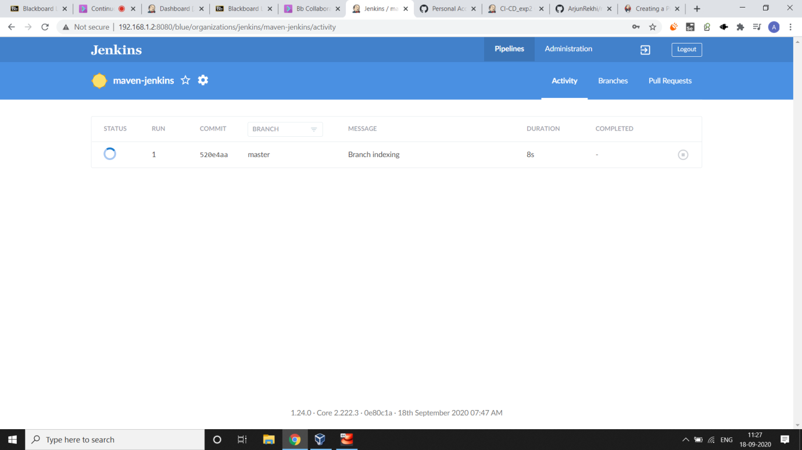

**Step 4:** Run the pipeline and the output can be seen as follows:

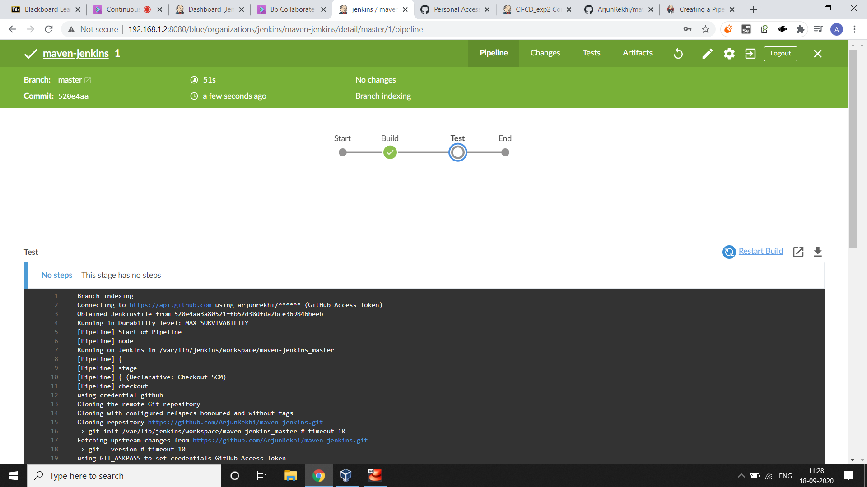

Submitted by:

Arjun Rekhi

500068109